Ballywalter Game & Country Living Fair

Ballwalter Estate
5th/6th May 2012
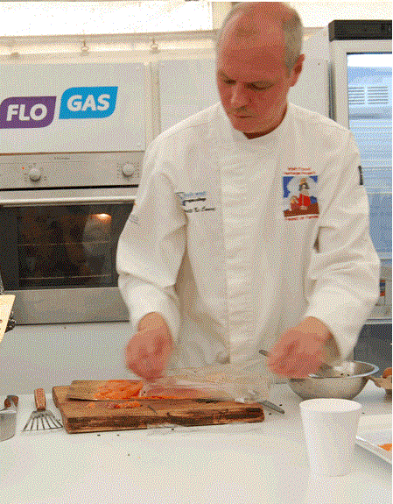

Go For Game

Recipes by Emmett McCourt

Victorian Potted Trout or Char

Ingredients:

3lb of Trout/Char Cooked skinned and boned
200g of salted butter
1/3rd clove of garlic pureed
Finally grated Zest of 1 lemon
1 tsp of thyme picked and chopped fine
1 tsp of Fresh Fennel Herb or Dill, Chopped Fine
1 pinch of Chilli
1 pinch of mace
Salt & pepper to season
Method:
In a heavy based pan, on a very low heat, melt the butter until the white milk solids drop to the bottom of the golden clarified butter. Skim off any white foamy solids from the top of the butter. Add the garlic, lemon zest and herbs and take the pan off the heat. Add the spices and stir. In a bowl add the skinned and boned trout, flake the flesh with a fork or by hand removing any bones you find. Add most of the clarified flavoured butter retaining some for the end, season to taste. Pack into Potted Ramekins or sealed Kilner jars pressing down well. Add the remaining clarified butter and seal the lid. This will keep up to two weeks in the fridge unopened. Consume within two days when opened. Serve with crusty bread or toast.

Pot Roasted Pheasant with
Bacon, Leeks and Carrots

Ingredients:

1 Brace of prepared pheasants
6 slices of Local Streaky bacon
50g of butter
1 leek cleaned and chopped along the length
2 carrots peeled and chopped
2 celery stocks chopped
1 fresh bay leaf
1 sprig of thyme
1 sprig of rosemary
1 clove of garlic peeled and roughly chopped
6 juniper berries
150ml -5fl oz of chicken stock
100ml of Roast gravy (chicken beef or game)
50 ml dry white wine
Salt and pepper to season
Method:
Preheat the oven to 160ºC, Gas 3, cover each of the pheasants with 3 slices of streaky bacon and tie them down with string. Melt the butter in a heavy based pot and add the vegetables, herbs and juniper berries, sweat gently without colour for 15 minutes turning regularly. Place the pheasants on top of the vegetables, add the wine, garlic and simmer for 5 minutes on top of the stove, add the chicken stock. Cover the pot with a lid and cook in the oven for 45 minutes. Take the lid off and put the pot back in the oven until the bacon is crispy, a further 10 minutes. Take the pheasants out of the pot and keep warm, (covered with tinfoil). Pick the herbs from the pot and reduce the cooking liquor. Cut the string off the pheasant and serve whole or cut the breasts & legs away from the carcass if desired. Serve with boiled potatoes and ladle the vegetables and sauce from the pot, over the Pheasant.
Braised Saddle of Wild Rabbit
with Fennel & Pistachio

Ingredients:

1 saddle of rabbit boned out and trimmed
Rabbit kidneys and livers 100g (optional)
Pork mince 100g
Chicken fillet minced 100g
Port 1 measure
Dry white wine 150ml
Local streaky bacon 200g
1 clove garlic chopped
Chopped shallots.
1 small bunch of thyme
1 small bulb of chopped fennel
1 carrot peeled and chopped
Pistachio nuts shelled and chopped 100g
1 onion peeled and chopped
1 celery stalk chopped
1 knob of butter
Chicken stock. 1 litre
Salt and pepper to season
Two sheets of cling film
Oil for frying

Method:
Preheat an oven to 160 c gas 4.

Place the pork and chicken mince into a bowl; chop the rabbit liver & kidneys adding to the stuffing. Sweat the shallots and garlic in butter with the pistachios chopped thyme and add to the stuffing when cooled. Add the port, mix and season. Add a little cracked egg to bind if necessary. Test the stuffing by placing a little in boiling water for 4 minutes until cooked, adjust the seasoning. Fill a piping bag with the stuffing and leave in Fridge.

Place the two sheets of cling film on a work bench with slices of bacon on top of the cling film, place the boned saddle of rabbit on top of the bacon flat. Pipe the stuffing up the middle of the rabbit. Roll the cling film slowly; turning both ends as you roll, to form a sausage shape with the stuffed saddle of rabbit. Turns both ends tightly and tie. Place in the fridge to set. Sweat the aromatic vegetables, Fennel and herbs in a deep roasting tray on top of the stove.

Add the stock, wine and cook for a further 10 minutes, add the rabbit to the roasting tray and baste with the cooking liquor, cover the tray and braise in the oven for 30 minutes basting regularly.

Pick out the rabbit and rest on a chopping board for 8 minutes.

Unwrap the cling film by cutting at both ends. Carve the rabbit saddle and serve with some of the reduced cooking liquid and fennel.

